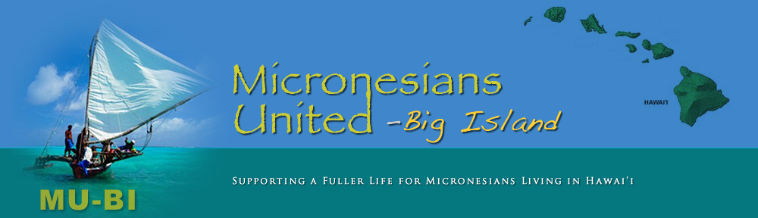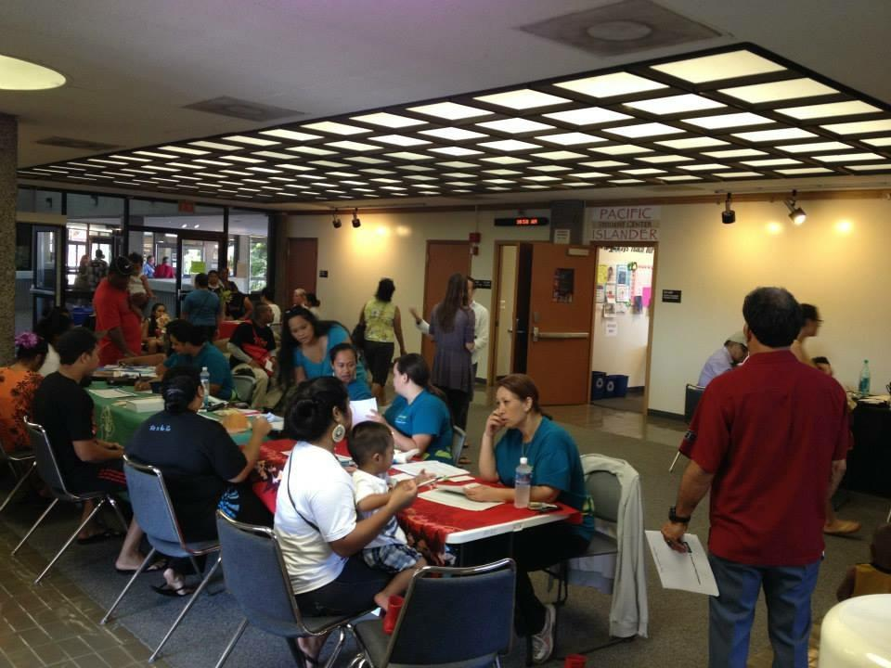

**COFA Community Health Fest Day 2018**

1. **We will have DHS personnel on site to help you find the right kind of healthcare plans for you and your family**
2. **Get Free Health Screening**
3. **Explore Healthy Living and Wellness Resources esources**

**200 West Kawili St. UH-Hilo**

**UCB-Room 207**

**Date: 11/17/18**

**Time: 9am-3pm**

***In partnership with Hawaii Island Workforce and Economic Development Ohana (HIWEDO), UH Hilo College of Pharmacy, and UH Hilo School of Nursing we present***